PROJECT DOCUMENTATION — FITBUDDY AI
1. PROJECT TITLE
FITBUDDY – AI FITNESS PLAN GENERATOR
DESCRIPTION
FitBuddy is an AI-powered fitness planning application designed to help users create personalized fitness and wellness plans. The application uses Google Gemini models to generate fitness recommendations based on information provided by the user.
The user can provide details such as fitness goals, age, fitness level, available workout time, preferred activities, and other relevant requirements. Based on the provided information, the AI generates a structured fitness plan.
The application aims to make fitness planning easier by providing personalized recommendations through an interactive web application.
2. PROJECT OBJECTIVE
The main objective of FitBuddy is to develop an AI-powered fitness assistant that can generate personalized fitness plans according to individual user requirements.
The system is designed to:
Collect user fitness information.
Understand the user's fitness goals.
Generate personalized workout recommendations.
Generate suitable fitness schedules.
Provide exercise suggestions.
Provide general nutrition guidance where included.
Use Google Gemini models to generate intelligent responses.
Present the generated plan in a simple and understandable format.
Help users organize their fitness activities.
3. TECHNOLOGIES USED
The technologies used in FitBuddy can include:
Frontend
HTML
CSS
JavaScript
Backend
Python
Flask
Artificial Intelligence
Google Gemini API / Gemini Models
Database
SQLite or another database, if implemented
Development Tool
Visual Studio Code
Environment
Python Virtual Environment
Supporting Technologies
Python-dotenv
REST API
JSON
The exact technologies should be adjusted according to the actual implementation of your project.
4. PROJECT SETUP
The FitBuddy project can be developed using Visual Studio Code.
A separate project folder is created for the application. The required programming environment and dependencies are installed before executing the project.
A Python virtual environment can be created to maintain the project dependencies separately.
The Gemini API key should be stored securely using environment variables instead of directly writing the key inside the source code.
The basic setup process is:
Create the FitBuddy project folder.
Install Python.
Install Visual Studio Code.
Create a Python virtual environment.
Install the required packages.
Configure the Gemini API key.
Create the frontend.
Create the backend.
Connect the Gemini model.
Run the application.
Test the fitness-plan generation functionality.
5. INTRODUCTION
FitBuddy is an AI-powered fitness planning application developed to provide personalized fitness assistance to users.
Fitness planning can be difficult because different people have different goals, fitness levels, available time, and preferences. A workout plan suitable for one person may not be suitable for another person.
FitBuddy attempts to solve this problem by using Generative Artificial Intelligence.
The user provides relevant information through the application. The backend processes the information and creates a suitable prompt for the Gemini model. Gemini analyzes the information and generates a personalized fitness plan.
The generated plan is then displayed to the user through the application interface.
The system demonstrates how Artificial Intelligence can be integrated into a web application to provide personalized fitness assistance.
6. PROJECT OVERVIEW
FitBuddy works as an AI-powered virtual fitness assistant.
The application receives information from the user through the frontend interface. The information may include:
Fitness goal
Age
Fitness level
Workout preference
Available workout time
Number of workout days
Equipment availability
Other user requirements
The frontend sends the information to the backend.
The backend validates the input and prepares an appropriate prompt for the Gemini model.
Gemini processes the prompt and generates the requested fitness plan.
The generated response is returned to the application and displayed to the user.
Main Features
User fitness information collection
AI fitness plan generation
Personalized workout recommendations
Exercise suggestions
Fitness schedule generation
General nutrition guidance, if implemented
AI-based fitness assistance
User-friendly interface
Plan history/storage, if implemented
7. PROBLEM STATEMENT
Many people want to follow a fitness routine but find it difficult to create a suitable workout plan.
A general fitness plan may not consider an individual's:
Fitness level
Personal goals
Available time
Workout preferences
Equipment availability
Experience level
Finding suitable exercises and organizing them into a structured plan can also require considerable time.
FitBuddy is designed to provide an AI-based solution for generating personalized fitness plans from user-provided information.
The application uses Gemini models to analyze user requirements and generate a structured fitness plan.
8. OBJECTIVES
The main objectives of FitBuddy are:
To develop an AI-powered fitness planning application.
To provide personalized fitness recommendations.
To generate workout plans using Gemini AI.
To understand user fitness goals.
To organize exercises into a structured routine.
To provide simple and understandable fitness recommendations.
To reduce the time required to create a fitness plan.
To provide an interactive fitness assistant.
To demonstrate the practical use of Generative AI.
To provide a foundation for future fitness-related features.
9. SCOPE OF THE PROJECT
FitBuddy focuses on AI-based fitness planning.
The application can be used to:
Create personalized workout plans.
Understand suitable exercises.
Organize weekly workout schedules.
Generate fitness recommendations.
Provide basic fitness guidance.
Support users in planning their fitness activities.
The project can be further extended with:
User authentication
Fitness progress tracking
Workout history
BMI calculation
Calorie tracking
Exercise videos
Voice-based fitness assistance
Mobile application
Wearable-device integration
Personalized notifications
Advanced fitness analytics
10. TECHNOLOGIES USED
Python
Python can be used as the primary programming language for the backend.
Python provides libraries and frameworks that make it suitable for developing AI-powered web applications.
Flask
Flask can be used as the backend web framework.
It handles:
Application routes
User requests
API requests
Data processing
Communication with Gemini
Responses to the frontend
Google Gemini
Google Gemini is the Artificial Intelligence component of FitBuddy.
Gemini receives the user's fitness information through a structured prompt and generates a personalized response.
For example:
User Input → Fitness Information → Prompt → Gemini → Fitness Plan
HTML
HTML is used to create the structure of the web application.
It can contain:
Input forms
Text fields
Buttons
Dropdown menus
Result sections
Navigation elements
CSS
CSS is used to control the visual appearance of FitBuddy.
It can be used for:
Layout
Colors
Fonts
Buttons
Cards
Forms
Responsive design
JavaScript
JavaScript is used to provide interactivity.
It can handle:
Form submission
Input validation
API communication
Displaying generated plans
Dynamic page updates
SQLite
If implemented, SQLite can be used to store:
User information
Generated fitness plans
Previous requests
Plan history
11. SYSTEM REQUIREMENTS
Hardware Requirements
Computer or laptop
Minimum 4 GB RAM
Keyboard and mouse
Internet connection
Sufficient storage space
Software Requirements
Windows/Linux/macOS
Python
Visual Studio Code
Web browser
Flask
Google Gemini API
SQLite, if used
Internet connection
12. PROJECT STRUCTURE
A typical FitBuddy project can be organized as follows:
FitBuddy/
│
├── app.py
├── requirements.txt
├── .env
│
├── templates/
│ └── index.html
│
├── static/
│ ├── css/
│ │ └── style.css
│ │
│ └── js/
│ └── script.js
│
└── database/
└── fitbuddy.db
Description
app.py
Main backend application.
index.html
Main frontend page.
style.css
Controls the design and appearance.
script.js
Handles frontend interactions.
.env
Stores configuration information such as the API key.
requirements.txt
Contains required Python packages.
fitbuddy.db
Database file if SQLite is used.
These filenames are an example. If you upload your actual project, I can replace them with your exact filenames.
13. SYSTEM ARCHITECTURE
FitBuddy follows a web-based AI application architecture.
The user interacts with the frontend.
The frontend collects fitness information and sends it to the backend.
The backend validates the information and creates a suitable prompt.
The prompt is sent to the Gemini AI model.
Gemini generates the personalized fitness plan.
The response is returned to the backend and then displayed to the user.
System Flow
User → Frontend → Backend → Gemini AI → Backend → Frontend → User
If a database is implemented:
User → Frontend → Backend → Gemini AI → Database → Frontend → User
14. FUNCTIONAL MODULES
FitBuddy can be divided into several functional modules:
User Input Module
Fitness Goal Module
AI Fitness Plan Generation Module
Workout Recommendation Module
Nutrition Guidance Module
Plan Display Module
History Module
Database Module, if implemented
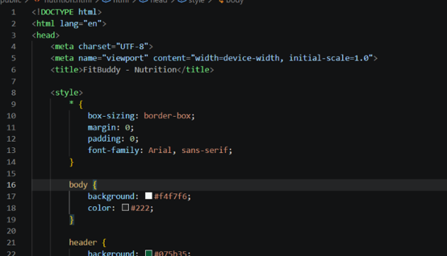
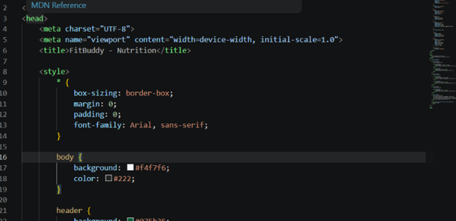

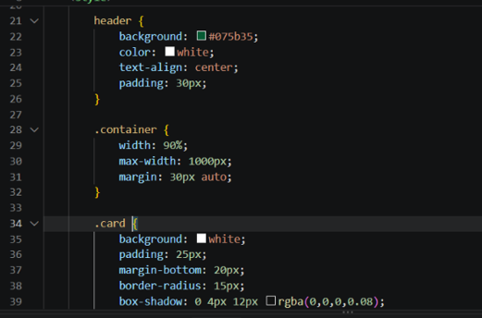
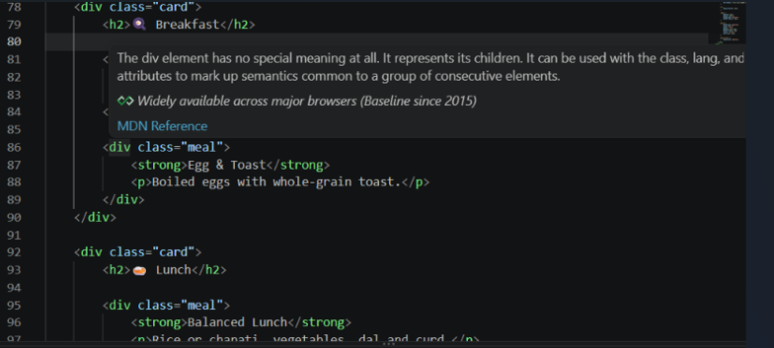
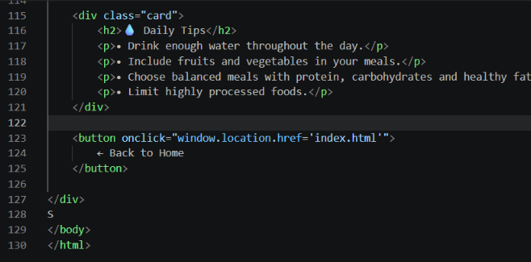
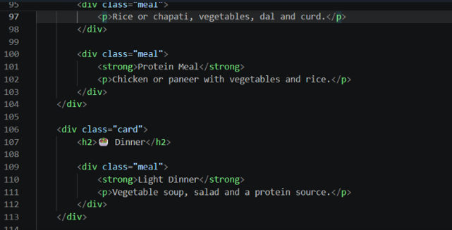

15. USER INPUT MODULE
The User Input Module collects information required to generate a personalized plan.
The user may enter:
Name
Age
Gender, if required
Height
Weight
Fitness level
Fitness goal
Workout duration
Workout frequency
Available equipment
Preferred workout type
Other requirements
The collected information is sent to the backend.
The system validates the required fields before generating the plan.
16. FITNESS GOAL MODULE
The Fitness Goal Module identifies what the user wants to achieve.
Possible goals can include:
Weight management
Muscle building
Strength improvement
General fitness
Flexibility
Endurance
Healthy lifestyle
The selected goal becomes an important part of the AI prompt.
The Gemini model uses the goal together with other user information to generate an appropriate plan.
Code:

17. AI FITNESS PLAN GENERATION MODULE
The AI Fitness Plan Generation Module is the main component of FitBuddy.
The user's information is converted into a structured prompt.
For example:
Create a personalized fitness plan based on the following user information:

Age: [User Age]
Fitness Level: [Level]
Goal: [Goal]
Workout Days: [Days]
Workout Duration: [Duration]
Equipment: [Equipment]

Generate a structured and easy-to-follow fitness plan.
The prompt is sent to Gemini.
Gemini generates a response based on the information.
The response is then displayed to the user.
18. WORKOUT PLAN MODULE
The Workout Plan Module generates structured exercise recommendations.
A generated plan may contain:
Warm-up
Main exercises
Sets
Repetitions
Rest periods
Cool-down
Weekly schedule
Example structure:
Day
Workout
Monday
Upper Body
Tuesday
Cardio
Wednesday
Rest
Thursday
Lower Body
Friday
Full Body
Saturday
Light Cardio
Sunday
Rest
The actual plan is generated according to the user's input.
19. NUTRITION GUIDANCE MODULE
If included in the project, FitBuddy can use Gemini to provide general nutrition guidance based on the user's fitness goal.
The system may generate suggestions related to:
Balanced meals
Protein sources
Fruits and vegetables
Hydration
Meal timing
General healthy eating habits
This should be presented as general wellness information, not as a medical diagnosis or individualized medical treatment.
20. GEMINI AI INTEGRATION
Google Gemini acts as the intelligence layer of FitBuddy.
The backend sends a structured prompt containing the user's fitness requirements.
The Gemini model processes the prompt and generates the response.
AI Processing Flow
User Information
↓
Prompt Creation
↓
Gemini AI
↓
Generated Fitness Plan
↓
Backend Processing
↓
Frontend Display
The use of Gemini allows the application to provide dynamic responses instead of relying only on predefined fitness plans.
21. DATABASE MANAGEMENT
If the project uses SQLite, the database can be used to store information related to generated plans.
Possible information includes:
Field
Description
ID
Unique record ID
User Input
Information provided by user
Fitness Goal
Selected fitness goal
AI Response
Generated fitness plan
Created At
Date and time
The database can allow users to access previous generated plans.
If your actual project does not use a database, this section should be removed from the final documentation.
22. API ENDPOINTS
If Flask REST endpoints are used, the application may contain endpoints such as:
Endpoint
Method
Purpose
/
GET
Loads the main page
/generate
POST
Generates fitness plan
/history
GET
Retrieves previous plans
The exact endpoints should be replaced with the endpoints in your actual code.
23. BACKEND PROCESSING
The backend performs the main processing tasks.
The backend can:
Start the Flask application.
Load environment variables.
Receive user information.
Validate the input.
Prepare the Gemini prompt.
Send the prompt to Gemini.
Receive the AI-generated response.
Process the response.
Store the response if a database is used.
Return the response to the frontend.
24. INPUT VALIDATION AND ERROR HANDLING
Input validation is important to ensure that the application receives the required information.
The application can check whether:
Required fields are filled.
Age is valid.
Weight and height values are valid.
A fitness goal has been selected.
Workout duration is valid.
If information is missing, the application should display an appropriate message.
For example:
“Please enter your fitness goal.”
The application should also handle Gemini API errors.
If the AI service is unavailable, the application should display an error message instead of crashing.
25. APPLICATION WORKFLOW
The overall workflow of FitBuddy is:
User opens the FitBuddy application.
User enters personal fitness information.
User selects a fitness goal.
User provides workout preferences.
User submits the form.
Frontend sends the information to the backend.
Backend validates the information.
Backend creates an AI prompt.
Prompt is sent to Gemini.
Gemini processes the request.
Gemini generates the fitness plan.
Backend receives the response.
Response is optionally stored in the database.
Generated plan is sent to the frontend.
User views the personalized fitness plan.
26. FRONTEND
The frontend provides the user interface for FitBuddy.
HTML
HTML creates the basic structure.
CSS
CSS provides:
Layout
Styling
Buttons
Forms
Cards
Responsive design
JavaScript
JavaScript handles:
User interactions
Form submission
Backend communication
Displaying AI responses
Error messages
The interface should be simple so that users can easily enter their fitness information and receive their plan.
27. APPLICATION EXECUTION
The application can be executed from the project directory.
The Python environment is activated and the required packages are installed.
The Flask application is then started.
The application runs on the local development server.
The user can open the local server address in a web browser and access FitBuddy.
28. TESTING
Testing is performed to verify that the application works correctly.
Test Case
Expected Result
Valid user information
Fitness plan generated
Empty fitness goal
Validation message
Valid fitness goal
Appropriate plan generated
Valid workout duration
Plan generated according to duration
Invalid age
Validation message
Invalid weight
Validation message
Gemini API available
AI response generated
Gemini API unavailable
Error message displayed
Multiple requests
Appropriate responses generated
Testing helps ensure that the major functions operate correctly.
29. ADVANTAGES
The major advantages of FitBuddy are:
Provides personalized fitness planning.
Uses Artificial Intelligence.
Generates plans quickly.
Reduces the effort required to create a workout routine.
Provides structured workout recommendations.
Offers an interactive user experience.
Can support different fitness goals.
Can be extended with additional AI features.
Demonstrates practical use of Gemini models.
Can be developed as a web or mobile application.
30. LIMITATIONS
The project may have the following limitations:
The application depends on the availability of the Gemini service.
Internet access is required for AI-generated responses.
AI-generated recommendations may not always be perfect.
Users should verify fitness recommendations when necessary.
The application may not consider every individual medical condition.
The basic version may have limited progress tracking.
AI-generated plans should not replace professional medical or fitness advice.
Database scalability may be limited if SQLite is used for a large number of users.
31. FUTURE ENHANCEMENTS
Several features can be added in future versions.
User Authentication
Users can create accounts and securely access their fitness plans.
Progress Tracking
The application can track:
Weight changes
Workout completion
Fitness goals
Progress over time
BMI Calculator
A BMI calculator can be added to provide basic body-mass information.
Calorie Tracking
Users can record daily food intake and activity.
Exercise Videos
Exercise demonstrations can be added to help users understand correct movements.
Voice Assistant
Voice-based interaction can allow users to communicate with FitBuddy using voice commands.
Mobile Application
FitBuddy can be developed as an Android or iOS application.
Wearable Integration
The application could integrate with fitness trackers and smartwatches.
Notifications
The application can send reminders for:
Workouts
Water intake
Meals
Fitness activities
Personalized Recommendations
The AI can analyze previous activity and provide increasingly personalized recommendations.
32. SECURITY CONSIDERATIONS
The Gemini API key should not be exposed directly in frontend code.
Environment variables can be used to store sensitive configuration values.
User information should be handled carefully.
If authentication is implemented, passwords should be securely stored using appropriate password-hashing techniques.
The application should also validate user input before processing it.

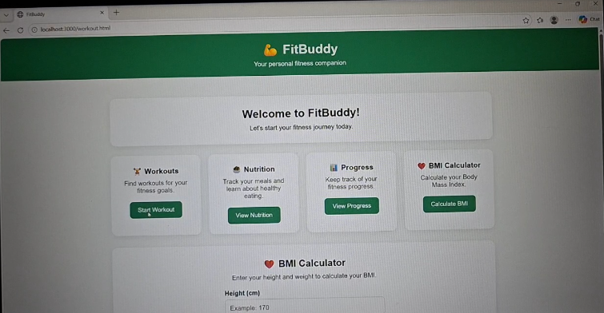
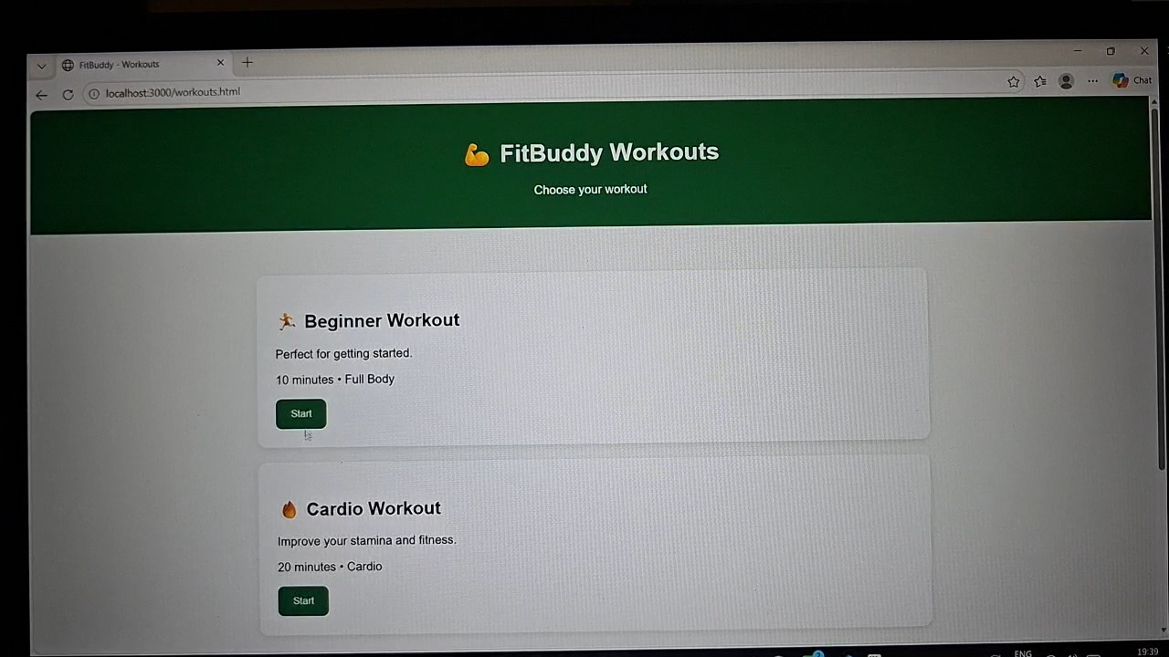

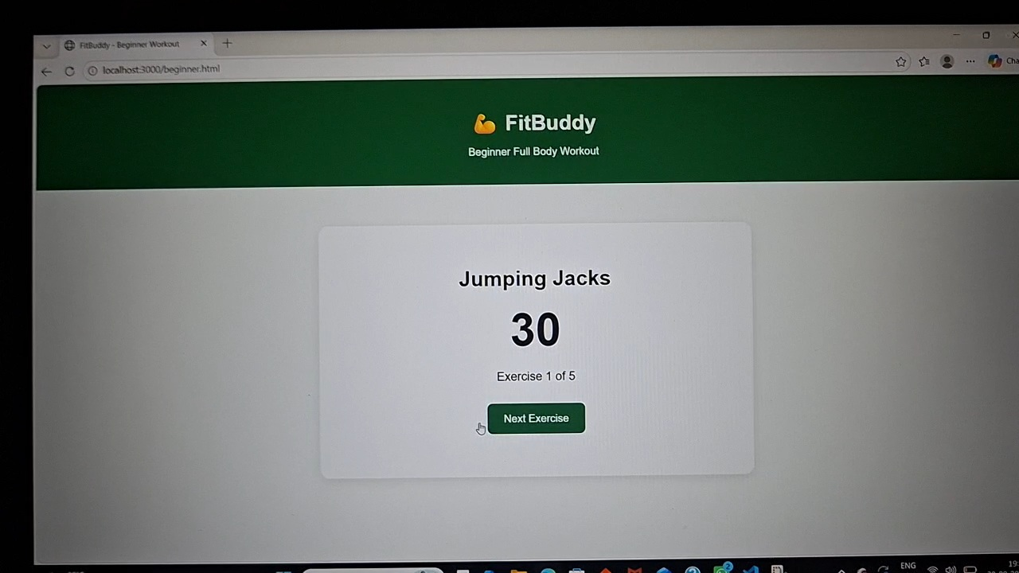

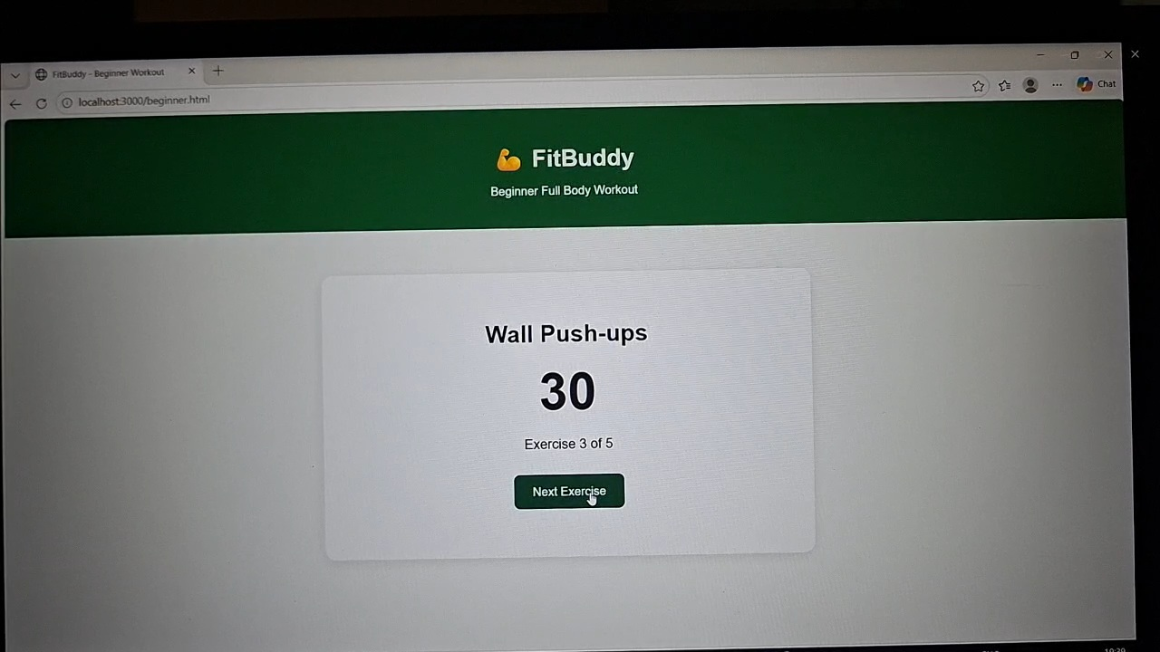

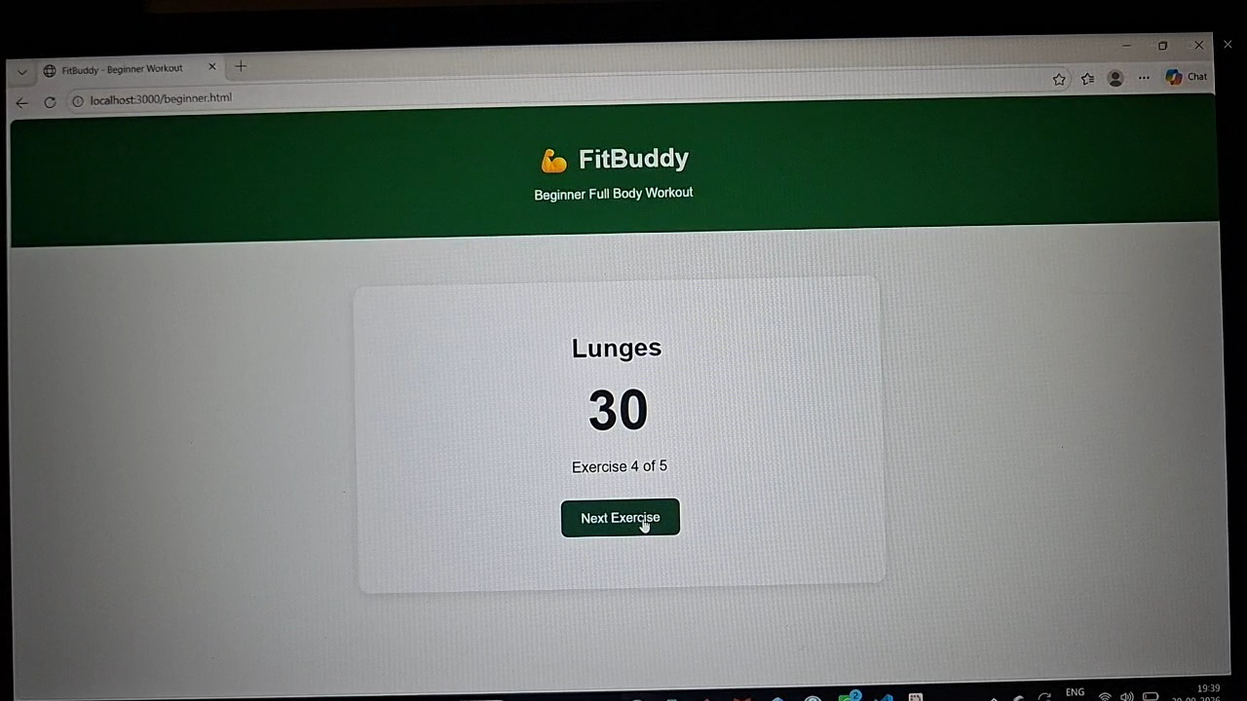

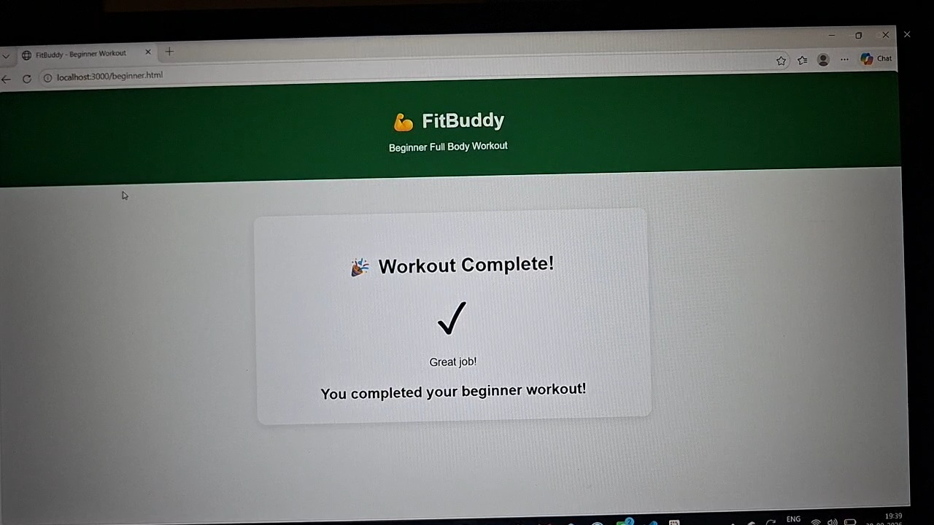

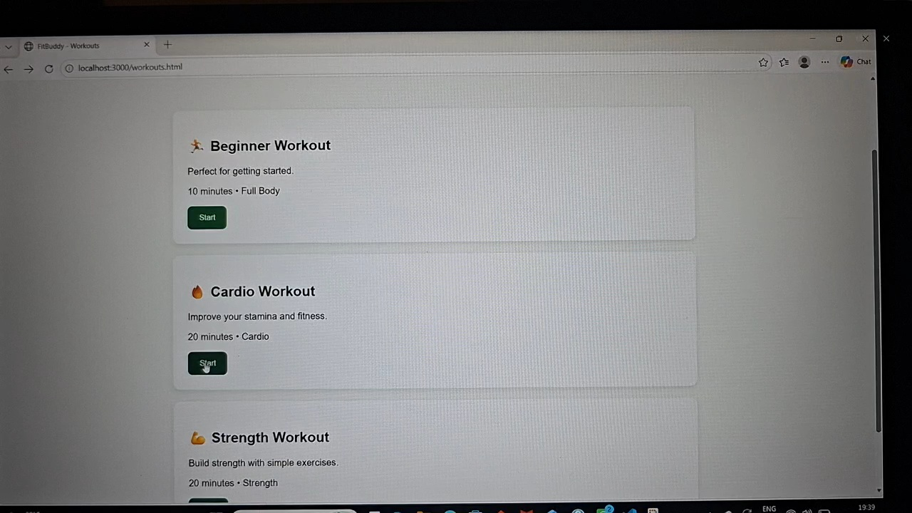

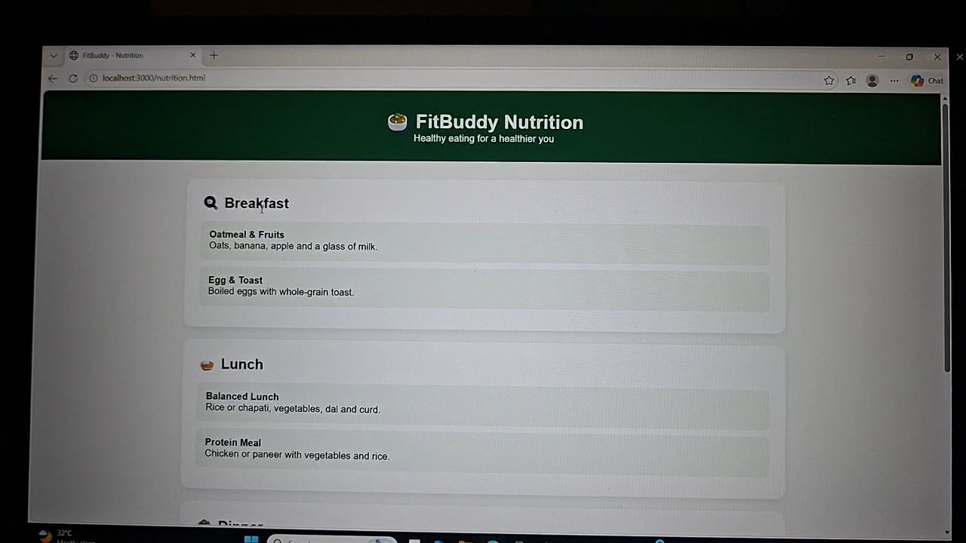

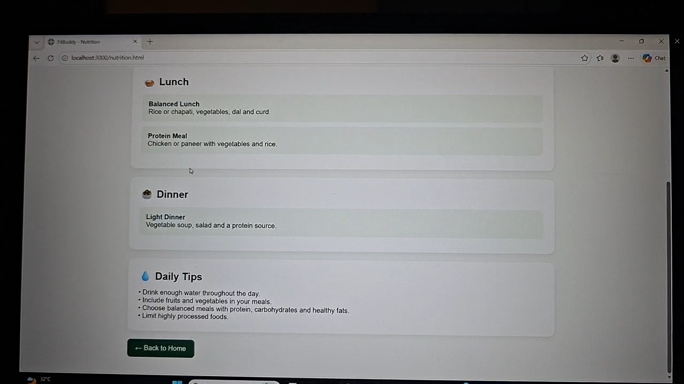

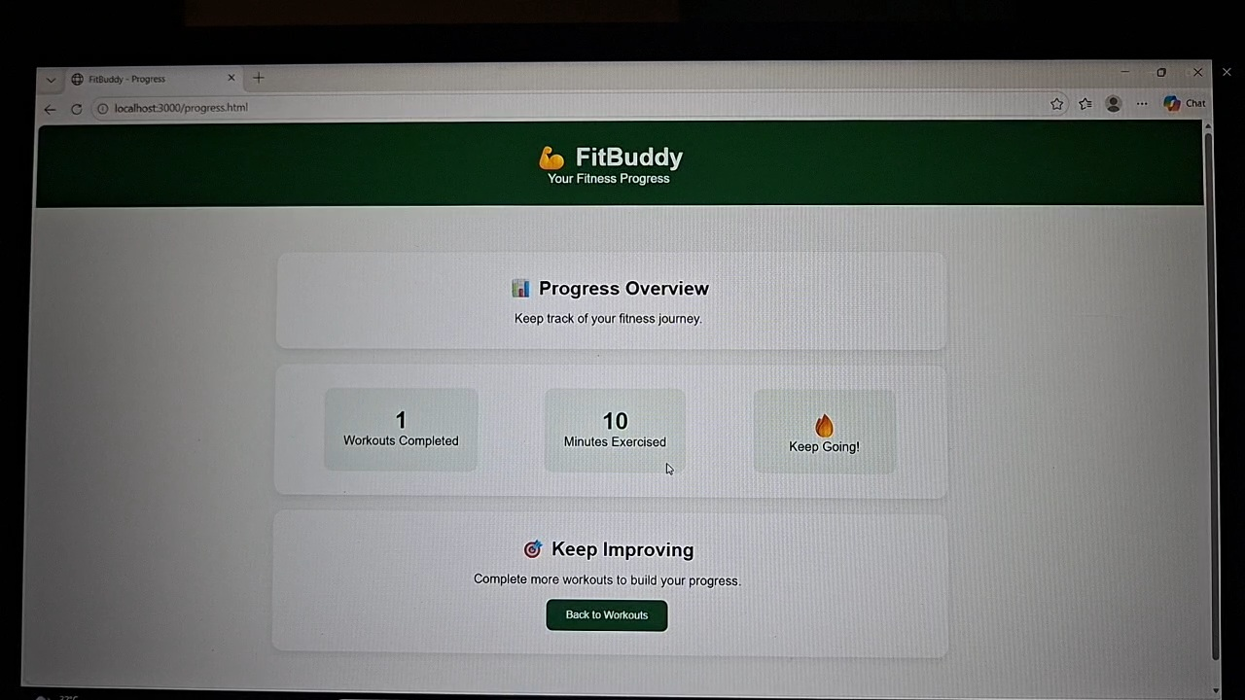

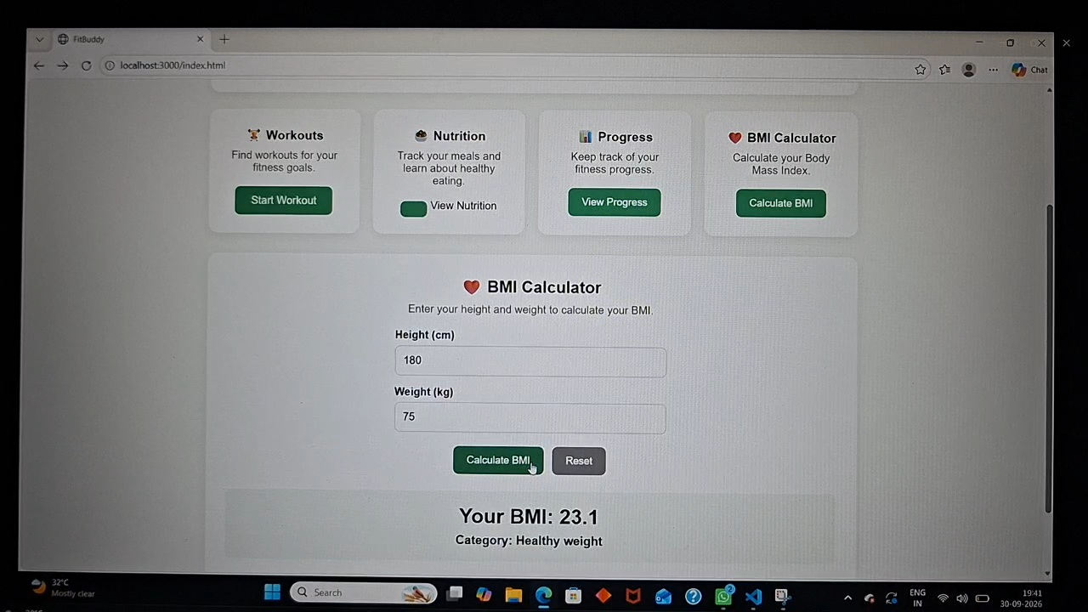

33. APPLICATION BENEFITS
FitBuddy demonstrates how Generative AI can be used in the fitness and wellness domain.
Instead of providing the same fixed workout routine to every user, the application can generate different recommendations according to the information provided by each user.
This makes the application more interactive and adaptable.
The project also provides practical experience with:
Web development
Python
Flask
APIs
Generative AI
Gemini models
Prompt engineering
Frontend development
Backend development
Database management
34. CONCLUSION
FitBuddy – AI Fitness Plan Generator is an AI-powered application designed to help users create personalized fitness plans.
The system collects relevant information from the user and processes it through a backend application. The backend creates a structured prompt and sends it to the Google Gemini model. Gemini generates a fitness plan based on the user's requirements, and the result is displayed through the application.
The project demonstrates the practical integration of Artificial Intelligence with web application development.
FitBuddy provides a foundation for developing more advanced fitness applications with features such as progress tracking, personalized recommendations, nutrition guidance, exercise videos, mobile applications, voice assistance, and wearable-device integration.
Overall, the project demon

